Code Evaluation

1. File Reading:
- The code opens the specified file, reads the content, and stores it in a variable for processing. This part works well for loading the input file content.
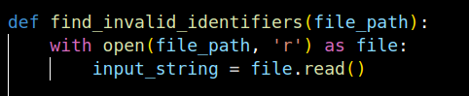

2. Cleaning Non-Identifier Parts:
- The code uses regular expressions to remove unnecessary parts such as keywords (`#include`, `void main()`, `int`, etc.) and symbols (`{}`, `=`, `+`, `*`, `,`, `.`), focusing on identifiers only.

```

3. Splitting and Identifying Potential Identifiers:
- After removing irrelevant elements, the code splits the content by whitespace to extract potential identifiers for analysis.
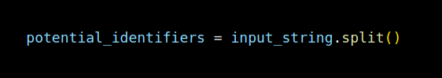

4. Defining Valid Identifier Rules:
- The code defines a regex pattern to ensure valid identifiers start with a letter or underscore and contain only alphanumeric characters, up to 10 characters in total.
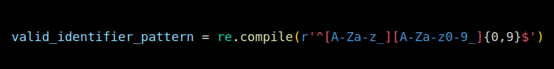

```

5. Reserved Words:
- A set of reserved words combines Python keywords with some C++ keywords, which are excluded from identifiers.

6. Loop for Detecting Invalid Identifiers:
- Each potential identifier is checked against the reserved words list and the regex pattern. Any identifier that fails these checks is added to `invalid_identifiers`.

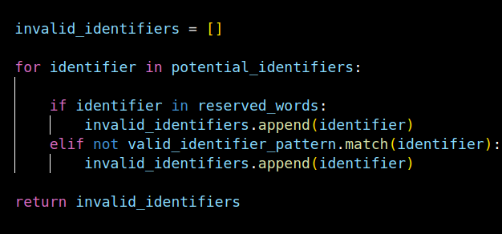

7. Output:
- The invalid identifiers are printed for inspection.
Challanges Faced:
Making the good sequence string for matching was a major challenge.

